**CHAPTER 1**

**INTRODUCTION**

* 1. **INTRODUCTION TO SQL**

SQL is used to communicate with a database. According to ANSI(American National Standards Institute),it is standard language for relational database management systems. SQL statements are used to perform tasks such as update data on a database or retrieve data from a database. Some comm9on relational database management systems that use SQL are: Oracle, Sybase, Microsoft SQL server, Access, Ingres, etc.

Although most database systems use SQL, most of them also have their own additional proprietary extensions that are usually only used on their systems. However, the standard SQL commands such as “Select”,” Insert”,” Update”,” Delete”,” Create”, and “Drop” can be used to accomplish almost everything that one needs to do with the database.

MySQL is the most popular Open source relational SQL database management system.MySQL is one of the best RDBMS being used for developing various web-based software applications. MySQL is developed, marketed and supported by MySQL AB, which is a Swedish company.

A database is a separate application that stores a collection of data. Each database has distinct API’s for creating, accessing, managing, searching and replicating the data it holds. Other kinds of data stores can also be used, such as files on the file system or large hash tables in memory but data fetching and writing would not be so fast and easy with those types of systems. Nowadays, we RDBMS to store and manage huge volume of data. MySQL is released under an open source license. So,you have nothing to pay to use it. MySQL is a very powerful program in its own right. It handles a large subset of the functionality of the most expensive and powerful database packages. MySQL uses a standard form of the well- known SQL data language. MySQL works on many operating systems and with many languages including PHP, PERL, C, C++, JAVA, etc. MySQL works very quickly and works well even with large data sets.

**1.2 INTRODUCTION TO FRONT END SOFTWARE**

The “front end languages” live in the browser. After you type in an address in the address bar at the top and hit Enter, your browser will receive an at least an HTML file from the web server.

Each of these languages performed a separate but very important function but the work harmoniously together to determine how the web page is STRUCTURED(HTML),how it LOOKS(CSS),and how its FUNCTIONS(JavaScript)

Front end web development is NOT design (You won’t be playing around in photoshop or anything), but a front-end developer does apply the work of designers to the web page by translating their well-designed layouts into real code. The front-end developer stands between the designer on one end and the back-end developer on the other, translating the design into code and plugging the data from the back-end developer into the right spot S.

PHP is a server-side scripting language designed primarily for web development but also used as a general-purpose programming language. Originally created by Rasmus Lerdorf in 1994, the PHP reference implementation is now produced by the PHP development team.

PHP code may be embedded into HTML or it can be used in combination with various web template systems, web content management systems and web frameworks. PHP code is usually processed by a PHP interpreter implemented as a module in the web server or as a Common Gateway Interface(CGI) executable. The web server software combines the result of the interpreted and executed PHP code, which may be any type of data, including images, with the generated web page. PHP code may also be executed with a command-line interface(CLI) and it can be used to implement stand-alone graphical applications.

**CHAPTER 2**

**REQUIREMENTS SPECIFICATION**

**2.1 SOFTWARE REQUIREMENTS**

Operating System : 32bit or 64bit WINDOWS Operating System, X64-

based processor

Database : MySQL

Scripting Language : PHP

Server : WAMP

**2.2 HARDWARE REQUIREMENTS**

Processor : Any processor above 500 MHz

RAM : 4.00 GB

Hard Disk : 1 TB

Compact Disk : CD-ROM, CD-R, CD-RW

Input device : Keyboard, Mouse

**CHAPTER 3**

**OBJECTIVE OF THE PROJECT**

**THE OBJECTIVES OF THE PROJECT ARE LISTED BELOW: -**

* **Improvement in control and performance**

The system is developed to cope up with the current issues and problems of restaurant. The system can add item, search item, display items, delete the items and also bug free.

* **Maintaining and managing well**

This database helps the restaurant to manage and maintains the information regarding categories, menu assigned manager and information regarding the order placed.

* **Save time**

This system allows the waiter to take orders/payments from customers and table status.

**CHAPTER 4**

**IMPLEMENTATION**

**4.1 ER DIAGRAM**

An entity relationship diagram(ERD) shows the relationships of entity sets stored in a database. An entity in this context is a component of data. In other words, ER diagrams illustrate the logical structure of databases.

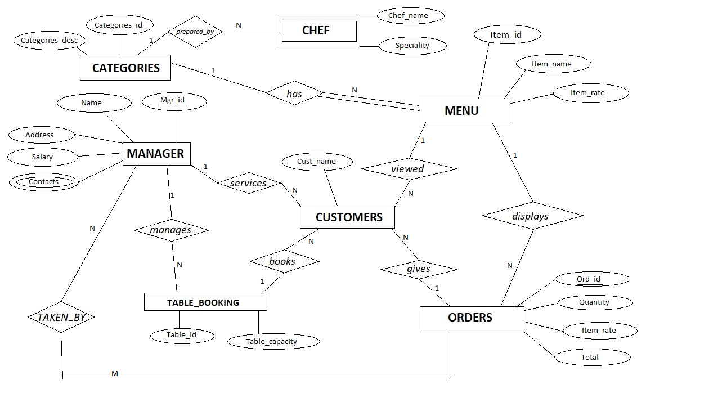

**FIGURE 4.1: ER DIAGRAM**

**4.2 MAPPING OF ER DIAGRAM TO RELATIONS**

**STEP 1: Mapping of regular entities**

Mapping of Regular Entity Types: For each regular (strong) entity type E in the ER diagram, create a relation R that includes all the simple attributes of E. Choose one of the key attributes as primary key. If the chosen key of E is composite, the set of simple attributes that form it will together form the primary key of R.

**CATEGORIES**

|  |  |
| --- | --- |
| **Categories_id** | Categories_desc |

**MENU**

|  |  |  |  |
| --- | --- | --- | --- |
| **Item_id** | Item_name | Item_rate |  |

**MANAGER**

|  |  |  |  |
| --- | --- | --- | --- |
| name | address | **Mgr_id** | salary |

**ORDERS**

|  |  |  |  |  |
| --- | --- | --- | --- | --- |
| **Ord_id** |  | quantity | Item_rate | total |

**STEP 2: Mapping of weak entities**

Mapping of Regular Entity Types: For each weak entity type W in the ER schema with owner entity type E, create a relation R & include all simple attributes (or simple components of composite attributes) of W as attributes of R. Also, include as foreign key attributes of R the primary key attribute(s) of the relation(s) that correspond to the owner entity type(s). The primary key of R is the combination of the primary key(s) of the owner(s) and the partial key of the weak entity type W, if any.

**CHEF**

|  |  |  |
| --- | --- | --- |
| Chef_name | speciality | **Categories_id**(f.k.) |

**STEP 3: Mapping of 1-1 Relationship**

Mapping of Binary 1:1 Relation Types: For each binary 1:1 relationship type R in the ER schema, identify the relations S and T that correspond to the entity types participating in R

**MENU**

|  |  |  |  |
| --- | --- | --- | --- |
| **Item_id** | Item_name | Item_rate | **Categories_id**(f.k.) |

**STEP 4: Mapping of 1-N Relationship**

Mapping of Binary 1: N Relationship Types: For each regular binary 1: N relationship type R, identify the relation S the at represent the participating entity type at the N-side of the relationship type. Include as foreign key in S the primary key of the relation T that represents the other entity type participating in R Include any simple attributes of the 1: N relation type as attributes of S.

**ORDERS**

|  |  |  |  |  |
| --- | --- | --- | --- | --- |
| **Ord_id** | **Item_id**(f.k.) | quantity | Item_rate | total |

**CUSTOMERS**

|  |  |  |  |  |
| --- | --- | --- | --- | --- |
| Cust_name | **Ord_id** | **Mgr_id** | **Item_id** | **Table_id** |

**TABLE_BOOKING**

|  |  |  |
| --- | --- | --- |
| Table_id | Table_capacity | **Mgr_id**(f.k.) |

**CHEF**

|  |  |  |
| --- | --- | --- |
| Chef_name | speciality | **Categories_id**(f.k.) |

**STEP 5: Mapping of M-N Relationship**

Mapping of Binary M: N Relationship Types: For each regular binary M: N relationship type R, create a new relation S to represent R. Include as foreign key attributes in S the primary keys of the relations that represent the participating entity types, their combination will form the primary key of S. Also include any simple attributes of the M: N relationship type (or simple

components of composite attributes) as attributes of S.

**TAKEN_BY**

|  |  |
| --- | --- |
| **Mgr_id**(f.k.) | **Order_id**(f.k.) |

**STEP 6:Mapping of multi-valued attributes**

Mapping of Multi valued attributes: For each multivalued attribute A, create a new relate ion R. This relation R will include an attribute corresponding to A, plus the primary key attribute K-as a foreign key in R-of the relate ion that represents the entity type of relationship type that has A as an attribute. The primary key of R is the combination of A and K. If the multivalued attribute is composite, we include its simple components.

**CONTACTS**

|  |  |
| --- | --- |
| Phone_num | **Mgr_id**(f.k.) |

**FIGURE 4.2: MAPPING ER DIAGRAM TO RELATIONS**

**4.3 SCHEMA DIAGRAM**

**CATEGORIES**

|  |  |
| --- | --- |
| **Categories_id** | Categories_desc |

**MENU**

|  |  |  |  |
| --- | --- | --- | --- |
| **Item_id** | Item_name | Item_rate | **Categories_id** |

**MANAGER**

|  |  |  |  |
| --- | --- | --- | --- |
| Name | Address | **Mgr_id** | Salary |

**TABLE_BOOKING**

|  |  |  |
| --- | --- | --- |
| **Table_id** | Table_capacity | **Mgr_id** |

**ORDERS**

|  |  |  |  |  |
| --- | --- | --- | --- | --- |
| **Ord_id** | **Item_id** | Quantity | Item_rate | Total |

**CUSTOMERS**

|  |  |  |  |  |
| --- | --- | --- | --- | --- |
| Cust_name | **Ord_id** | **Mgr_id** | **Item_id** | **Table_id** |

**TAKEN_BY**

|  |  |
| --- | --- |
| **Ord_id** | **Mgr_id** |

**CONTACTS**

|  |  |
| --- | --- |
| Phone_num | **Mgr_id** |

**CHEF**

|  |  |  |
| --- | --- | --- |
| Chef_name | Speciality | **Categories_id** |

**FIGURE 4.3: SCHEMA DIAGRAM**

**4.4 NORMALIZE THE RELATIONS**

Database normalization, or simply normalization, is the process of organizing the columns(attributes) and tables(relations) of a relational database to reduce data redundancy and improve data integrity. Normalization involves arranging attributes in relations based on dependencies between attributes.

1. **First Normal Form**

As per First normal form, no two rows of data must contain repeating group of information. Each set of columns must have a unique value, such that multiple columns cannot be used to fetch the same row. Each table should be organized into rows, and each row should have a primary key that will distinguishes it as unique.

**MENU**

|  |  |  |  |
| --- | --- | --- | --- |
| **Item_id** | Item_name | Item_rate | **Categories_id** |

**ORDERS**

|  |  |  |  |  |
| --- | --- | --- | --- | --- |
| **Ord_id** | **Item_id** | quantity | Item_rate | Total |

All the tables in the database are normalized to 1NF as all the attributes are atomic.

1. **Second Normal Form (2NF):**

A table is in 2NF if it is in 1NF and if all non-key attributes are fully functionally dependent on all of the key.

**MANAGER**

|  |  |  |  |
| --- | --- | --- | --- |
| name | address | **Mgr_id** | salary |

1. **Third Normal Form(3NF):**
2. A table is in 3NF if it is in 2NF and if it has no transitive dependency.
3. X->Y, Y->Z, X->Z
4. According to CODD’s definition a relation schema R is in 3NF.
5. It satisfies 2NF and no non-prime attribute of R is transitively dependenton the primary.
6. Since the database is relationally-schema mapped the relations are normalized and do not have any 3NF.

All tables are satisfied to be in 3NF.

**4.5 CREATION OF TABLES**

**CREATE TABLE CATEGORIES**

CREATE TABLE CATEGORIES

(

CATEGORIES_ID VARCHAR (10) PRIMARY KEY,

CATEGORIES_DESC VARCHAR (20)

);

**CREATE TABLE MENU**

CREATE TABLE MENU

(

ITEM_ID VARCHAR (5) PRIMARY KEY,

ITEM_NAME VARCHAR (20),

ITEM_RATE DOUBLE NOT NULL,

CATEGORIES_ID VARCHAR (5),

FOREIGN KEY(CATEGORIES_ID) REFERENCES CATEGORIES(CATEGORIES_ID) ON DELETE CASCADE

);

**CREATE TABLE MANAGER**

CREATE TABLE MANAGER

(

MGR_ID VARCHAR (10) PRIMARY KEY,

NAME VARCHAR (20),

ADDRESS VARCHAR (30),

SALARY FLOAT NOT NULL

);

**CREATE TABLE TABLE_BOOKING**

CREATE TABLE TABLE_BOOKING

(TABLE_ID VARCHAR (5) PRIMARY KEY,

TABLE_CAPACITY INT,

MGR_ID VARCHAR (10),

FOREIGN KEY(MGR_ID) REFERENCES MANAGER(MGR_ID) ON DELETE CASCADE

);

**CREATE TABLE ORDERS**

CREATE TABLE ORDERS

(

ORD_ID VARCHAR (5) PRIMARY KEY,

QUANTITY INT,

ITEM_RATE DOUBLE NOT NULL,

TOTAL DOUBLE NOT NULL,

ITEM_ID VARCHAR (5),

FOREIGN KEY(ITEM_ID) REFERENCES MENU(ITEM_ID)ON DELETE CASCADE

);

**CREATE TABLE CUSTOMERS**

CREATE TABLE CUSTOMERS

(

CUST_NAME VARCHAR (20),

TABLE_ID VARCHAR (5),

ITEM_ID VARCHAR (5),

ORD_ID VARCHAR (5),

MGR_ID VARCHAR (10),

FOREIGN KEY(TABLE_ID) REFERENCES TABLE_BOOKING(TABLE_ID)ON DELETE CASCADE,

FOREIGN KEY(ITEM_ID) REFERENCES MENU(ITEM_ID)ON DELETE CASCADE,

FOREIGN KEY(ORD_ID) REFERENCES ORDERS(ORD_ID)ON DELETE CASCADE,

FOREIGN KEY(MGR_ID) REFERENCES MANAGER(MGR_ID)ON DELETE CASCADE

);

**CREATE TABLE TAKEN_BY**

CREATE TABLE TAKEN_BY

(

ORD_ID VARCHAR (5),

MGR_ID VARCHAR (10),

FOREIGN KEY(ORD_ID) REFERENCES ORDERS(ORD_ID)ON DELETE CASCADE,

FOREIGN KEY(MGR_ID) REFERENCES MANAGER(MGR_ID) ON DELETE CASCADE

);

**CREATE TABLE CONTACTS**

CREATE TABLE CONTACTS

(

MGR_ID VARCHAR (10),

PHONE_NUM INT (10),

FOREIGN KEY(MGR_ID) REFERENCES MANAGER(MGR_ID)ON DELETE CASCADE

);

**CREATE TABLE CHEF**

CREATE TABLE CHEF

(

CHEF_NAME VARCHAR (30),

SPECIALITY VARCHAR (30),

CATEGORIES_ID VARCHAR (10),

FOREIGN KEY(CATEGORIES_ID) REFERENCES CATEGORIES(CATEGORIES_ID) ON DELETE CASCADE);

**4.6 INSERTION OF TUPLES**

**INSERT VALUES TO CATEGORIES**

INSERT INTO CATEGORIES VALUES ("1", "INDIAN");

INSERT INTO CATEGORIES VALUES ("2", "CHINESE");

INSERT INTO CATEGORIES VALUES ("3", "TANDOOR");

INSERT INTO CATEGORIES VALUES ("4", "DESSERT");

INSERT INTO CATEGORIES VALUES ("5", "COLDRINKS");

INSERT INTO CATEGORIES VALUES ("6", "SNACKS");

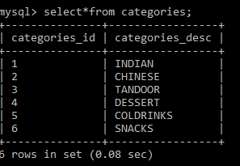

**INSERT VALUES TO MENU**

INSERT INTO MENU VALUES ("IN10", "PANEER BTM", 120,"1)";

INSERT INTO MENU VALUES ("IN11", "PANEER KADHAI", 130,"1");

INSERT INTO MENU VALUES ("IN12", "PANEER DO PYAZA", 120,"1");

INSERT INTO MENU VALUES ("IN13", "PANEER MUTAR", 110,"1");

INSERT INTO MENU VALUES ("IN14", "PANEER KOLHAPURI", 110,"1");

INSERT INTO MENU VALUES ("IN15", "PANEER AFGHANI", 140,"1");

INSERT INTO MENU VALUES ("CH10", "PANEER CHILLY", 110,"2");

INSERT INTO MENU VALUES ("CH11", "PANEER MANCHURIAN", 110,"2");

INSERT INTO MENU VALUES ("CH12", "PANEER CHILLY DRY", 100,"2");

INSERT INTO MENU VALUES ("CH13", "PANEER PEPPER DRY", 100,"2");

INSERT INTO MENU VALUES ("CH14", "VEG MANCHURIAN", 90,"2");

INSERT INTO MENU VALUES ("CH15", "VEG NOODLES", 70,"2");

INSERT INTO MENU VALUES ("CH16", "PANEER NOODLES", 80,"2");

INSERT INTO MENU VALUES ("CH17", "MIX VEG FRIED RICE", 65,"2");

INSERT INTO MENU VALUES ("TA10", "PANEER TIKKA", 140,"3");

INSERT INTO MENU VALUES ("TA11", "HARA BHARA KABAB", 130,"3");

INSERT INTO MENU VALUES ("TA12", "MALAI KABAB", 150,"3");

INSERT INTO MENU VALUES ("TA13", "RESHMI KABAB", 150,"3");

INSERT INTO MENU VALUES ("TA14", "SEEKH KABAB", 140,"3");

INSERT INTO MENU VALUES ("TA15", "NAAN", 25,"3");

INSERT INTO MENU VALUES ("TA16", "BUT NAAN", 30,"3");

INSERT INTO MENU VALUES ("TA17", "TAN ROTI", 20,"3");

INSERT INTO MENU VALUES ("TA18", "BUT TAN ROTI", 25,"3");

INSERT INTO MENU VALUES ("TA19", "MASALA KULCHA", 35,"3");

INSERT INTO MENU VALUES ("DE10", "GULAB JAMUN", 15,"4");

INSERT INTO MENU VALUES ("DE11", "HOT CHOCO BROWNIE", 85,"4");

INSERT INTO MENU VALUES ("DE12", "ICE_CREAM", 25,"4");

INSERT INTO MENU VALUES ("CD10", "COKE", 15,"5");

INSERT INTO MENU VALUES ("CD11", "PEPSI", 15,"5");

INSERT INTO MENU VALUES ("CD12", "FANTA", 15,"5");

INSERT INTO MENU VALUES ("CD13", "SPRITE", 15,"5");

INSERT INTO MENU VALUES ("CD14", "THUMPS UP", 15,"5");

INSERT INTO MENU VALUES ("CD15", "CD WITH ICE_CREAM", 50,"5");

INSERT INTO MENU VALUES ("SN10", "SAMOSA", 12,"6");

INSERT INTO MENU VALUES ("SN11", "KACHORI", 12,"6");

INSERT INTO MENU VALUES ("SN12", "TIKKI CHAT", 25,"6");

INSERT INTO MENU VALUES ("SN13", "PAPRI CHAT", 20,"6");

INSERT INTO MENU VALUES ("SN14", "SAMOSA CHAT", 30,"6");

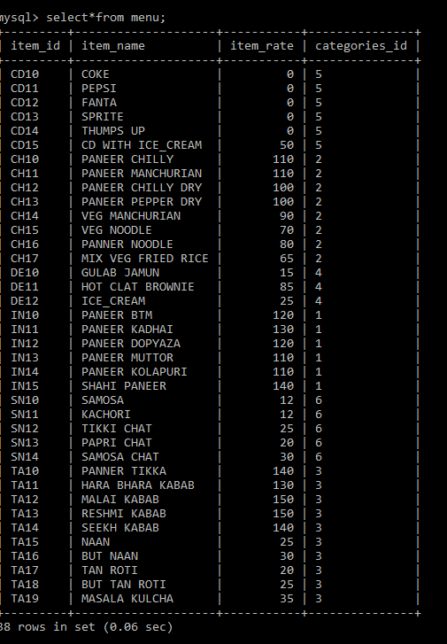

**INSERT VALUES TO MANAGER**

INSERT INTO MANAGER VALUES ("101", "AMIT", "BENGALURU",10000);

INSERT INTO MANAGER VALUES ("102", "RAHUL", "BENGALURU",11000);

INSERT INTO MANAGER VALUES ("103", "AKHIL", "MUMBAI",11500);

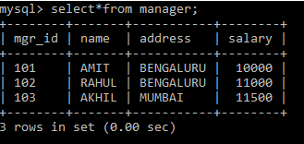

**INSERT VALUES TO TABLE_BOOKING**

INSERT INTO TABLE_BOOKING VALUES ("T1",2 ,"101");

INSERT INTO TABLE_BOOKING VALUES ("T2",4 ,"101");

INSERT INTO TABLE_BOOKING VALUES ("T3",6 ,"101");

INSERT INTO TABLE_BOOKING VALUES ("T4",8 ,"101");

INSERT INTO TABLE_BOOKING VALUES ("T5",2 ,"102");

INSERT INTO TABLE_BOOKING VALUES ("T6",4 ,"102");

INSERT INTO TABLE_BOOKING VALUES ("T7",6 ,"102");

INSERT INTO TABLE_BOOKING VALUES ("T8",4 ,"103");

INSERT INTO TABLE_BOOKING VALUES ("T9",6 ,"103");

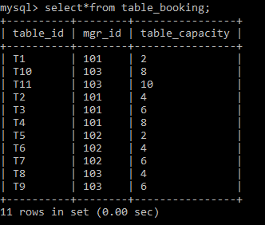

**INSERT VALUES TO ORDERS**

INSERT INTO ORDERS VALUES ("OD101",4,15,60,"CD13");

INSERT INTO ORDERS VALUES ("OD102",4,110,440,"CH10");

INSERT INTO ORDERS VALUES ("OD103",4,70,280,"CH15");

INSERT INTO ORDERS VALUES ("OD104",2,120,240,"IN10");

INSERT INTO ORDERS VALUES ("OD105",2,110,220,"IN14");

INSERT INTO ORDERS VALUES ("OD106",2,150,300,"TA13");

INSERT INTO ORDERS VALUES ("OD107",2,140,280,"TA14");

INSERT INTO ORDERS VALUES ("OD108",3,30,90,"TA16");

INSERT INTO ORDERS VALUES ("OD109",2,35,70,"TA19");

INSERT INTO ORDERS VALUES ("OD110",4,85,340,"DE11");

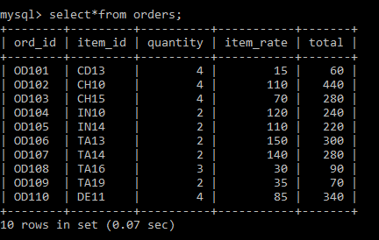

**INSERT VALUES TO CUSTOMERS**

INSERT INTO CUSTOMERS VALUES ("ANURAG","T2","CH10","OD102","101");

INSERT INTO CUSTOMERS VALUES ("ANURAG","T2","CH15","OD103","101");

INSERT INTO CUSTOMERS VALUES ("ANURAG","T2","CD13","OD101","101");

INSERT INTO CUSTOMERS VALUES ("RISHI" ,"T5","IN10","OD104","102");

INSERT INTO CUSTOMERS VALUES ("RISHI","T5","TA13","OD106","102");

INSERT INTO CUSTOMERS VALUES ("RISHI","T5","TA16","OD108","102");

INSERT INTO CUSTOMERS VALUES ("SURAJ","T8","IN14","OD105","103");

INSERT INTO CUSTOMERS VALUES ("SURAJ","T8","TA19","OD109","103");

INSERT INTO CUSTOMERS VALUES ("SURAJ","T8","TA14","OD107","103");

INSERT INTO CUSTOMERS VALUES ("SURAJ","T8","DE11","OD110","103");

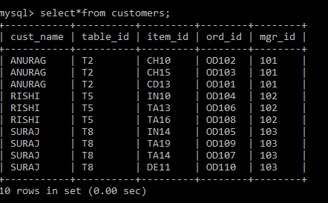

**INSERT VALUES TO TAKEN_BY**

INSERT INTO TAKEN_BY VALUES ("OD102","101");

INSERT INTO TAKEN_BY VALUES ("OD103","101");

INSERT INTO TAKEN_BY VALUES ("OD101","101");

INSERT INTO TAKEN_BY VALUES ("OD104","102");

INSERT INTO TAKEN_BY VALUES ("OD106","102");

INSERT INTO TAKEN_BY VALUES ("OD108","102");

INSERT INTO TAKEN_BY VALUES ("OD105","103");

INSERT INTO TAKEN_BY VALUES ("OD109","103");

INSERT INTO TAKEN_BY VALUES ("OD107","103");

INSERT INTO TAKEN_BY VALUES ("OD110","103");

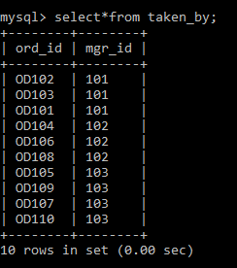

**INSERT VALUES TO CONTACTS**

INSERT INTO CONTACTS VALUES ("101",983501234);

INSERT INTO CONTACTS VALUES ("102",983506789);

INSERT INTO CONTACTS VALUES ("103",983501122);

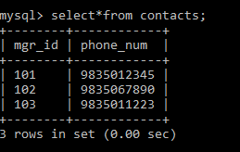

**INSERT VALUES TO CHEF**

INSERT INTO CHEF VALUES ("BALAJI","INDIAN","1");

INSERT INTO CHEF VALUES ("PRAKASH","CHINESE","2");

INSERT INTO CHEF VALUES ("KEDAR","TANDOOR","3");

INSERT INTO CHEF VALUES ("VIKASH","DESSERT","4");

INSERT INTO CHEF VALUES ("MOHAN","SNACKS","6");

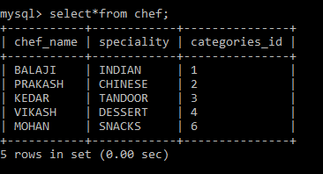

**4.7 CREATION OF TRIGGERS**

The trigger is made such that when a new record is inserted into a CD table, it automatically inserts the current date and time when the record is inserted.

CREATE TRIGGER TOTAL

BEFORE INSERT ON ORDERS

FOR EACH ROW

SET NEW.TOTAL=NEW.ITEM_RATE*NEW.QUANTITY;

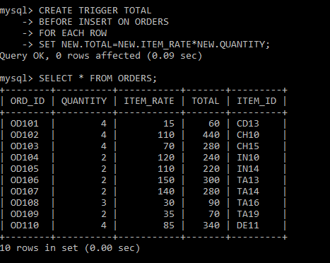

**4.8 CREATION OF STORED PROCEDURES**

This stored procedure is used to merge two tables with the help of primary key.

DELIMITER $$

CREATE PROCEDURE MANAGERS ()

BEGIN

SELECT T. TABLE_ID, T.MGR_ID, C. CUST_NAME, T. TABLE_CAPACITY

FROM TABLE_BOOKING T, CUSTOMERS C

WHERE T.MGR_ID=C.MGR_ID;

END

$$

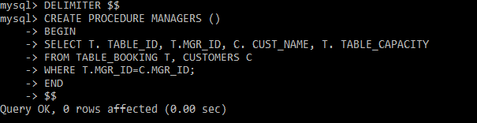

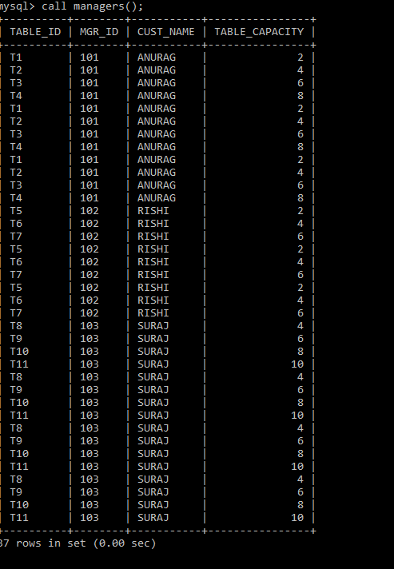

**CHAPTER 5**

**FRONT END DESIGN**

**5.1 SYSTEM DESIGN**

System design is the process of defining the architecture, components, modules, interfaces, and data for a system to satisfy specified requirements. System design could see it as the application of systems theory to product development. There is some overlap with the disciplines of system analysis, system architecture and systems engineering. If the border topic of product development “blends the perspective of marketing, design, and manufacturing into a single approach to product development,” then design is the act of taking the marketing information and creating the design of the product to be manufactured. System design is therefore the process of defining and developing systems to satisfy specified requirements of the user.

Until the 1990’s systems design had a crucial and respected role in the data processing industry. In 1990’s standardization of hardware and software resulted in the ability to build modular systems. The increasing importance of software running on generic platforms has enhanced the discipline of software engineering.

Object-oriented analysis and design methods are becoming the most widely used methods for computer system design. The UML has become the standard language in object-oriented analysis and design. It is widely used for modelling software systems and organizations.

System design is one of the most important phases of software development process. The purpose of the design is to plan the solution of a problem specified by the requirement documentation. In other words, the first step in the solution to the problem is the design of the project.

**5.2 FRONT END CODE**

**CREATING FRONT END PAGE TO LINK ALL TABLES**

<!DOCTYPE html>

<html>

<head>

<title>

RESTAURANT MANAGEMENT DATABASE

</title>

</head>

<body>

<b><marquee direction="right" style="font-family:Black And White Picture; font-size:25pt ;color: #FC0404" scrollamount="7"> WELCOME TO MY DATABASE! </marquee></b>

<h1>

<link href="https://fonts.googleapis.com/css?family=Allerta+Stencil" rel="stylesheet">

<center>

<h1 style="font-size: 42" ><font style="border: 4px groove yellow;" color=#43FF00 face="Allerta Stencil" >RESTAURANT MANAGEMENT </font></h1>

</center>

<style>

.column

{

}

body

{

background: url("Avillez.jpg") no-repeat;

background-size:cover;

}

ul

{

margin:3pc;

padding:0.1px;

list-style:none;

}

ul li a

{

background-color:#B2CEB0;

opacity:.8;

line-height:40px;

text-align:center;

font-size:25px;

margin-right:7px;

margin-left: 5px;

text-decoration:underline;

text-align: center;

color:navy blue;

display:block;

}

ul li a:hover

{

background-color:red;

color:black;

background-size: contain;

}

ul li ul li

{

display:none;

}

ul li:hover ul li

{

display:block;

}

</style><br>

<ul>

<li><a href="categories.html" >CATEGORIES</a></li>

<li><a href="menu.html">MENU</a></li>

<li><a href="manager.html">MANAGER</a></li>

<li><a href="tablebooking.html">TABLE_BOOKING</a></li>

<li><a href="orders.html">ORDERS</a></li>

<li><a href="customers.html" >CUSTOMERS</a></li>

<li><a href="contacts.html">CONTACTS</a></li>

<li><a href="takenby.html">TAKEN_BY</a></li>

<li><a href="chef.html">CHEF</a></li>

</ul>

<br>

</h1>

<style>

{

padding-bottom: 2px;

box-sizing: border-box;

}

.column

{

float: left;

width: 33.33%;

padding: 5px;

}

.row::after

{

content: "";

clear: both;

display: table;

}

</style>

</head>

<body>

<

</body>

</html>

**FRONT END CODE FOR INSERTION**

<!DOCTYPE html>

<html>

<head>

<meta name="viewport" content="width=device-width, initial-scale=1">

<style>

body {

font-family: Arial, Helvetica, sans-serif;

background-color: lightskyblue;

}

{

box-sizing: border-box;

}

/* Add padding to containers */

.container {

padding: 15px;

background-color: white;

}

/* Full-width input fields */

input[type=text], input[type=text]

{

width: 90%;

padding: 14px;

margin: 5px 0 22px 0;

display: inline-block;

border-radius: 10px;

background: #F0F0F4;

}

input[type=text]:focus, input[type=text]:focus {

background: white;

outline: none;

}

/* Overwrite default styles of hr */

hr {

border: 1px solid #f1f1f1;

margin-bottom: 25px;

}

/* Set a style for the submit button */

.registerbtn {

background-color:navy;

color: white;

padding: 15px 21px;

margin: 8px 0;

border-radius: 10px;

cursor: pointer;

width: 25%;

opacity: 0.5;

}

.registerbtn:hover {

opacity: 1;

}

a {

color: mediumseagreen;

}

.signin {

background-color: #ffffff;

text-align: center;

}

</style>

</head>

<form ACTION="categoriesinsert.php"METHOD="POST">

<div class="container">

<center><h1 style="color:#B22222" size="45";>GIVE APPROPRIATE DETAILS</h1></center>

<hr>

<label for="CATEGORIES_ID"><b>CATEGORIES ID</b></label>

<input type="text" placeholder="Enter CATE_ID" name="CATEGORIES_ID" required>

<label for="CATEGORIES_DESC"><b>CATEGORIES DESC</b></label>

<input type="text" placeholder="Enter CATE DESC" name="CATEGORIES_DESC" required>

<button type="update" class="registerbtn">UPDATE</button>

<button type="reset" class="registerbtn">RESET</button>

</div>

</form>

</body>

</html>

**FRONT END CODE FOR SEARCH**

<html>

<head>

</head>

<style>

table{

border-collapse: collapse;

width: 60%;

padding: 150px;

margin-left: 280px;

} s

th, td {

text-align: center;

padding: 8px;

}

tr:nth-child(even)

{

background-color: #f2f2f2;

font-family: "arial";

font-weight: bold;

}

th {

background-color: mediumslateblue;

color: white;

font-family: "verdana";

font-weight: bold;

}

input[type=text] {

width: 110px;

box-sizing: border-box;

border: 2px solid #ccc;

border-radius: 9px;

font-size: 16px;

background-color: white;

background-position: 10px 10px;

background-repeat: no-repeat;

padding: 25px 20px 22px 10px;

-webkit-transition: width 0.4s ease-in-out;

transition: width 0.4s ease-in-out;

font-weight: bold;

font-size: 30px;

}

input[type=text]:focus {

width: 60%;

}

div{

font-family: "verdana";

font-weight: bold;

font-size: 30px;

font-style: bold;

margin-left:25px;

margin-top: 35px;

}

.btn{

background-color:green;

color: white;

padding: 16px 20px;

margin: 8px 20px 20px 50px;

border-radius: 21px;

cursor: pointer;

width: 10%;

opacity: 0.5;

align-content: center;

font-family: "verdana";

font-weight: bold;

}

.btn:hover {

opacity: 1;

}

b{

font-family: "verdana";

background-color: lightcyan;

color: black;

margin-left:80px;

border-radius: 8px;

text-align: center;

font-size: 30px;

width: 85%;

}

p{

font-family: "verdana";

background-color: lightcyan;

color: black;

margin-top:4px;

border-radius: 8px;

text-align: center;

font-size: 30px;

margin-left:80px;

width: 35%;

}

</style>

<body style="background-color: lavender">

<form action="categoriessearch.php" method="post">

<div>Enter CATEGORIES_ID:<input type="text" name="CATEGORIES_ID"><br></div>

<br><br>

<button type="submit" value ="Find" class="btn">SEARCH</button>

</form>

</body>

</html>

**FRONT END CODE FOR DISPLAY**

<!DOCTYPE html>

<html>

<head>

<title>DISPLAY CATEGORIES</title>

<style>

b{

font-size: 20px;

font-family: 'Arial';

padding: 2px;

text-align: center;

}

table

{

border-collapse: collapse;

width: 100%;

color: #588c7e;

font-family: monospace;

font-size: 15px;

text-align: left;

font-family:"Verdana";

font-weight: bold;

text-align: center;

}

th

{

background-color: maroon;

color: white;

}

h1{

font-family: "times new roman";

font-size: 40px;

border: 9px solid grey;

border-radius: 17px;

color: maroon;

}

td{

padding: 12px;

font-family: "Verdana";

}

tr:nth-child(even) {background-color: #87CEFA;

border-radius: 14px;}

</style>

</head>

<body style="background-color: lavender">

<h1><center><font style="border:9px solid grey">DISPLAY OF CATEGORIES TABLE </font></center></h1>

<table>

<tr>

**FRONT END CODE FOR DELETE**

<!DOCTYPE html>

<html>

<head>

<title>

CATEGORIES DELETION

</title>

</head>

<style>

b{

font-size: 30px;

font-family: 'Arial';

padding: 27px 62px;

}

input[type=text] {

width: 110px;

box-sizing: border-box;

border: 2px solid #ccc;

border-radius: 9px;

font-size: 16px;

background-color: white;

background-position: 10px 10px;

background-repeat: no-repeat;

padding: 25px 20px 22px 10px;

-webkit-transition: width 0.4s ease-in-out;

transition: width 0.4s ease-in-out;

font-weight: bold;

font-size: 30px;

}

input[type=text]:focus {

width: 60%;

}

div{

font-family: "verdana";

font-weight: bold;

font-size: 30px;

font-style: bold;

margin-left:25px;

margin-top: 35px;

}

.btn{

background-color: forestgreen;

color: white;

padding: 16px 10px;

margin: 8px 20px 20px 50px;

border-radius: 24px;

cursor: pointer;

width: 10%;

opacity: 0.7;

align-content: center;

font-family: "verdana";

font-weight: bold;

-webkit-box-shadow: 0px 6px 0px green;

-moz-box-shadow: 0px 6px 0px green;

box-shadow: 0px 6px 0px green;

-webkit-transition: all .1s ease-in-out;

-moz-transition: all .2s ease-in-out;

transition: all .2s ease-in-out;

-webkit-transform: translate(0, 5px) rotateX(25deg);

-moz-transform: translate(0, 4px);

transform: translate(0, 4px)

}

.btn:hover

{

opacity: 1;

background-color:forestgreen;

}

</style>

<body style="background-color: lavenderblush">

<form action="categoriesdelete.php" method="POST">

<div>Enter CATEGORIES_ID:<input type="text" name="CATEGORIES_ID"><br></div>

<br><br>

<button type="submit" value ="Find" class="btn">Delete</button>

</form>

</body>

</html>

**5.3 CONNECTIVITY TO DATABASE**

**CONNECTING FRONT END OF INSERT TO BACK END**

<?php

if(isset($_POST['CATEGORIES_ID']) &&isset($_POST['CATEGORIES_DESC'])):

$categoriesid = $_POST['CATEGORIES_ID'];

$categoriesdesc = $_POST['CATEGORIES_DESC'];

$link = new mysqli('localhost','root','','restaurant');

if($link->connect_error)

die('connection error: '.$link->connect_error);

$sql3 = "INSERT INTO CATEGORIES(categories_id, categories_desc) VALUES('".$categoriesid."', '".$categoriesdesc."')";

$result = $link->query($sql3);

if($result > 0):

echo 'Successfully Inserted into CATEGORIES table.';

else:

echo 'Unable to post';

endif;

$link->close();

die();

endif;

?>

**CONNECTING FRONT END OF SEARCH TO BACK END**

<?php

$host="localhost";

$user="root";

$password="";

$con= new mysqli($host,$user,$password,"restaurant");

if ($con->connect_error) {

die("Connection failed: " . $con->connect_error);

}

if ($_SERVER["REQUEST_METHOD"] == "POST")

{

$n=$_POST['CATEGORIES_ID'];

echo "<b><br>Entered CATEGORIES_ID is $n and the Corresponding table is shown Below <br><br></b>";

$sql="select * from categories where CATEGORIES_ID='$n'";

$result = $con->query($sql);

if ($result->num_rows> 0) {

echo "<br><br><br><br><table><tr><th>CATEGORIES_ID</th><th>CATEGORIES_DESC</th></tr>";

while($row = $result->fetch_assoc()) {

echo "<tr><td>" . $row["CATEGORIES_ID"]. "</td><td>" .$row["CATEGORIES_DESC"]. "</td></tr>";

}

echo "</table>";

} else {

echo "<p>There is no such CATEGORIES_ID exist. Please Enter Correct CATEGORIES_ID</p>";

}

}

$con->close();

?>

<p style="font-family: Black And White Picture"><a href="categories.html"><font style="color:black">GO BACK</font></a></p>

</body>

</html>

**CONNECTING FRONT END OF DISPLAY TO BACK END**

<?php

$conn = mysqli_connect("localhost", "root", "", "restaurant");

if ($conn->connect_error) {

die("Connection failed: " . $conn->connect_error);

}

$sql = "SELECT CATEGORIES_ID, CATEGORIES_DESC FROM categories";

$result = $conn->query($sql);

if ($result->num_rows> 0)

{

while($row = $result->fetch_assoc())

{

echo "<tr><td>" . $row["CATEGORIES_ID"]. "</td><td>" .$row["CATEGORIES_DESC"]. "</td></tr>";

}

echo "</table>";

}

else

{

echo "0 results";

}

$conn->close();

?>

**CONNECTING FRONT END OF DELETE TO BACK END**

<?php

$servername = "localhost";

$username = "root";

$password = "";

$dbname = "restaurant";

$con = new mysqli($servername, $username, $password, $dbname);

if ($_SERVER["REQUEST_METHOD"] == "POST")

{

$a=$_POST['CATEGORIES_ID'];

if($a!="")

{

$sql1 = "SELECT * from categories where CATEGORIES_ID='$a'";

$result = mysqli_query($con,$sql1);

if(mysqli_num_rows($result)>0)

{

$sql3="DELETE from categories where CATEGORIES_ID='$a'"; // student is the table name

mysqli_query($con,$sql3);

echo "<b>Record with CATEGORIES_ID = $a is deleted successfully.<b>";

}

else

{

echo "<b>!!!Error in Deleting Record!!!<br> Record '$a' was not found in database.<b>" ;

}

}else{

echo "CATEGORIES_ID Field is Empty";

}

$con->close();

}

?>

<p style="font-family: Black And White Picture"><a href="categories.html"><font style="color:black">GO BACK</font></a></p>

</body>

</html>

**CHAPTER 6**

**TESTING**

This chapter gives the outline of all testing methods that are carried out to get a bug free system. Quality can be achieved by testing the product using different techniques at different phases of the project development. The purpose of testing is to discover error. Testing is the process of trying to discover every conceivable fault or weakness in a work product. It provides a way to check the functionality of components sub-assemblies and/or a finished product. It is the process of exercising software with the intent of ensuring that the software system meets its requirements and user expectations and does not fail in an unacceptable manner. There are various types of test. Each test type addresses a specific testing requirement.

**6.1 TESTING PROCESS: -**

Testing is an integral part of software development. Testing process certifies whether the product that is developed complies with the standards that I was designed to. Testing process involves building of test cases against which the product has to be used.

**6.2 TESTING OBJECTIVE: -**

The main objectives of testing process are as follows.

1. Testing is a process of executing a program with the intent of finding an error.

2. A good test case is one that has high probability of finding undiscovered error.

3. A successful test is one that uncovers the undiscovered error.

**6.3 TEST CASE**

The test cases provided here test the most important features of the project.

**TEST CASES FOR THE PROJECT**

|  |  |  |  |  |
| --- | --- | --- | --- | --- |
| **S.NO** | **TEST INPUT** | **EXPECTED RESULT** | **OBSERVED RESULT** | **REMARKS** |
| 1 | INSERT A RECORD | New tuple should be inserted | Query OK 1 row effected or inserted | PASS |
| 2 | SEARCH A RECORD | Display the record | Required record displayed | PASS |
| 3 | DISPLAY A RECORD | Display the record | record  displayed | PASS |
| 4 | DELETE A RECORD | Delete the record | Query OK 1 row affected or Row Deleted | PASS |
| 5 | CREATE TRIGGER | Trigger Created | Query OK Trigger Created | PASS |
| 6 | CREATE STORED PROCEDURES | Stored procedures created | Query OK Stored Procedures Created | PASS |

**CHAPTER 7**

**RESULTS**

This section describes the snaps of “Restaurant database”. The snapshots are shown below for each module.

**SNAPSHOTS: -**

* This page describes the login page of the restaurant: -

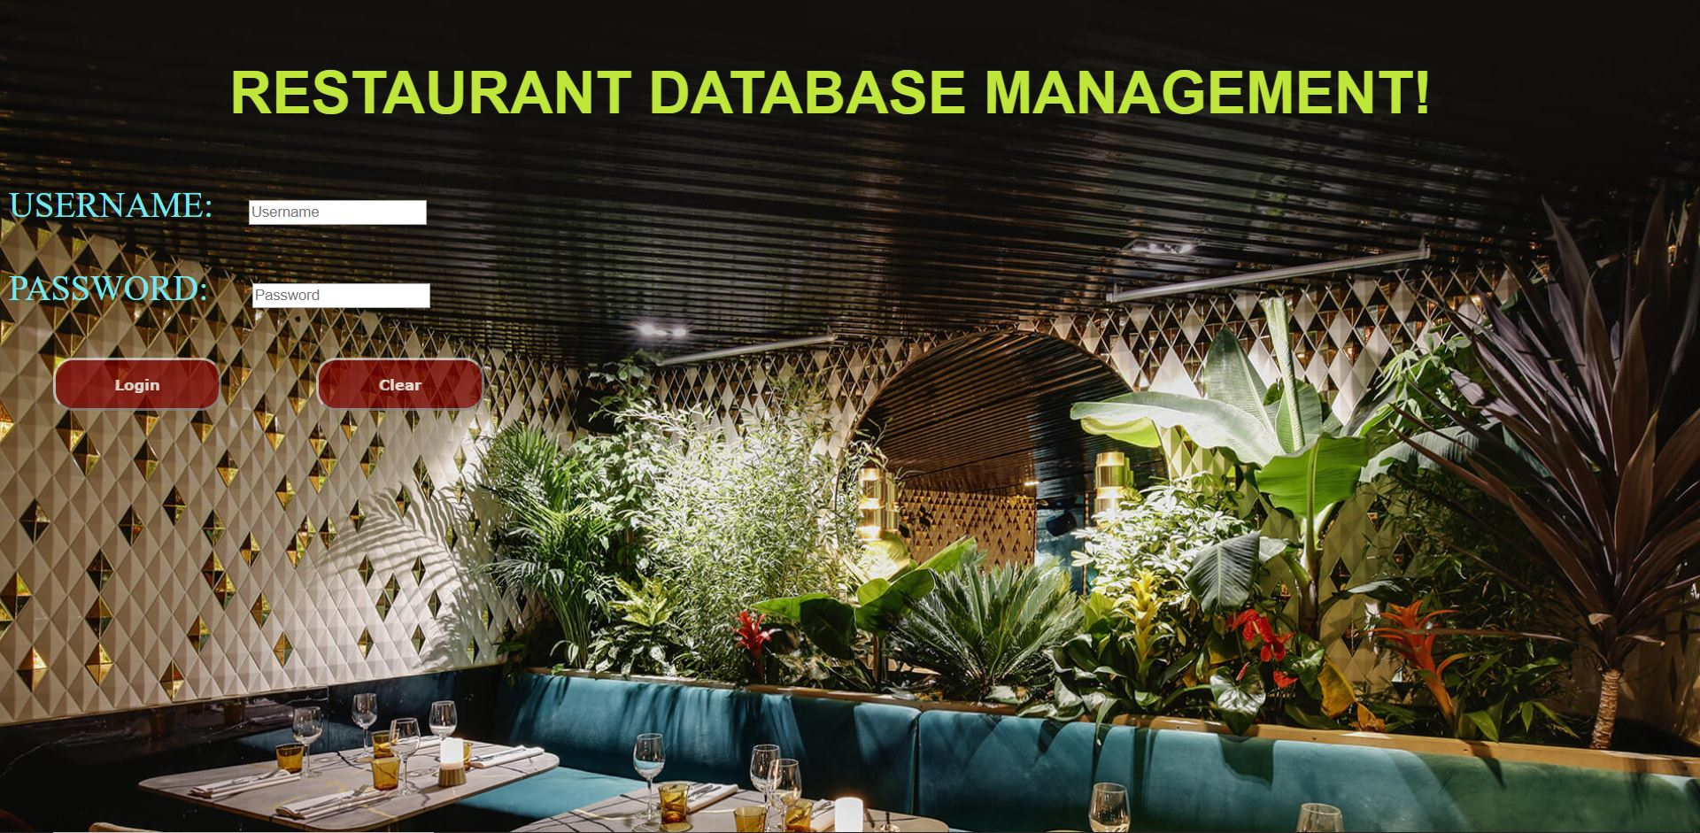

**FIGURE 7.1: LOGIN PAGE OF RESTAURANT.**

* This is the main page that shows all the operations which are present in Restaurant database.

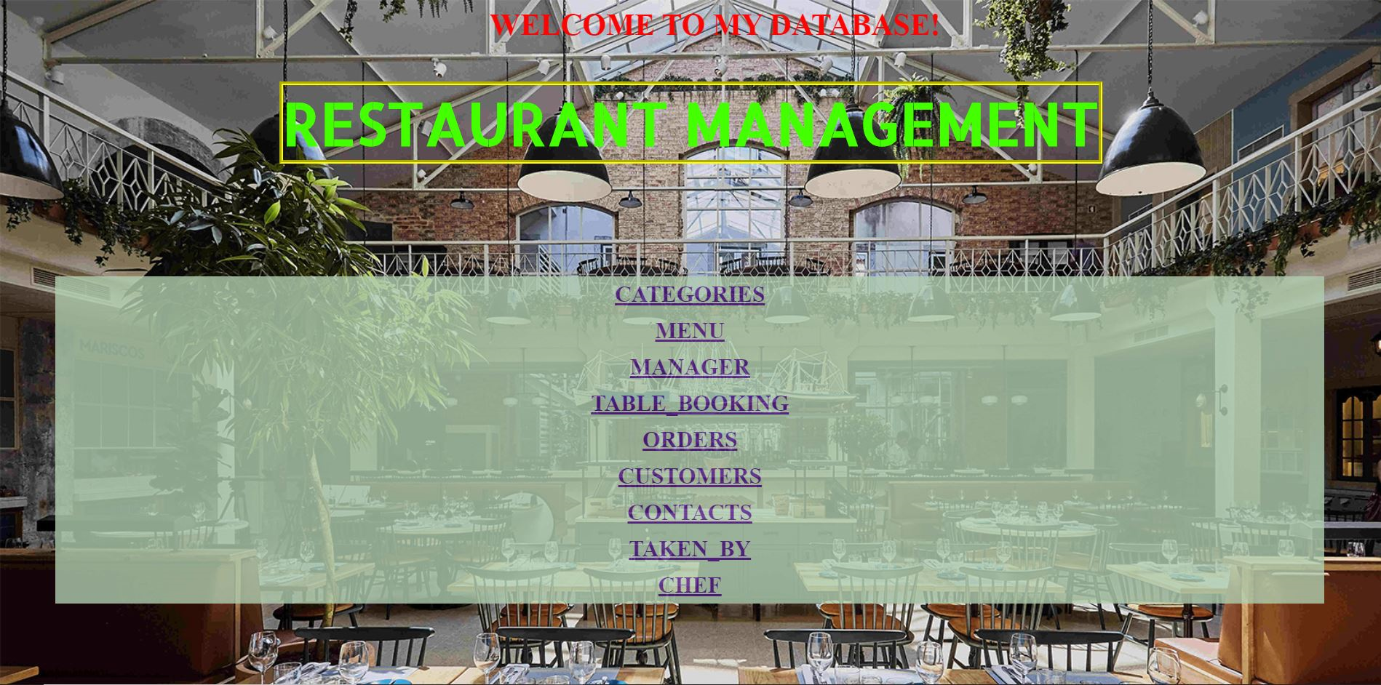**FIGURE 7.2 RESTAURANT DATABASE MAIN PAGE**

* This is the entity main page that shows all the operations which are present in Restaurant database.

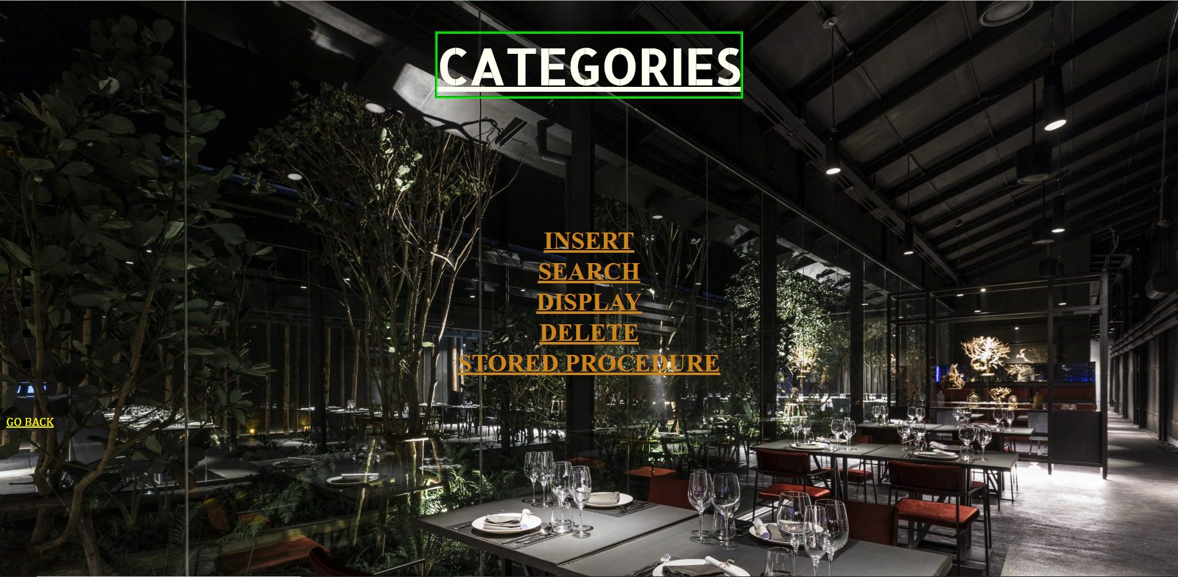

**FIGURE 7.3 CATEGORIES ENTITY PAGE**

* Thisis the insertion page where we can insert in the front end which gets stored in back end.

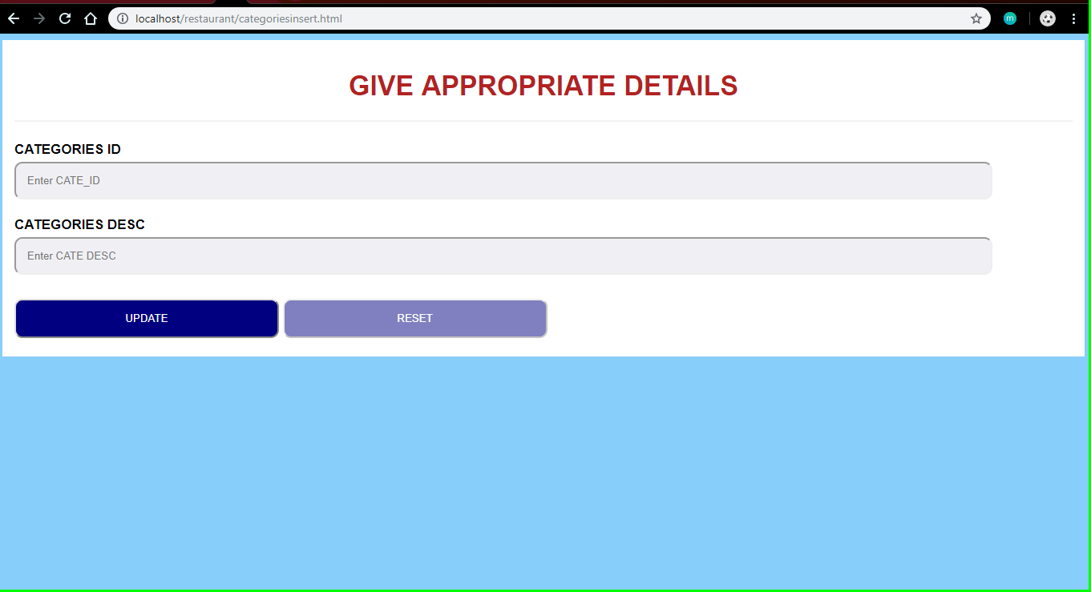

**FIGURE 7.4: INSERTION PAGE**

* This is the page where we can search for the details of any table from front end.

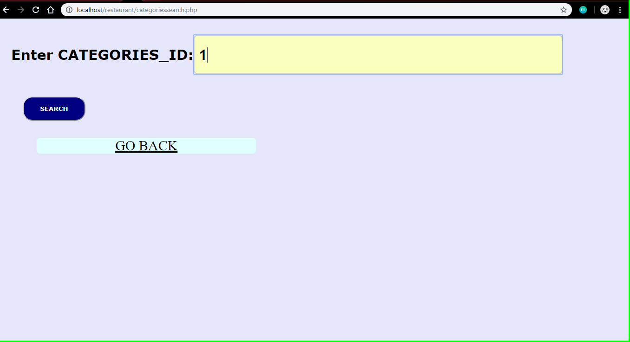

**FIGURE 7.5: SEARCH PAGE**

* This is the page which displays the values at the front end.

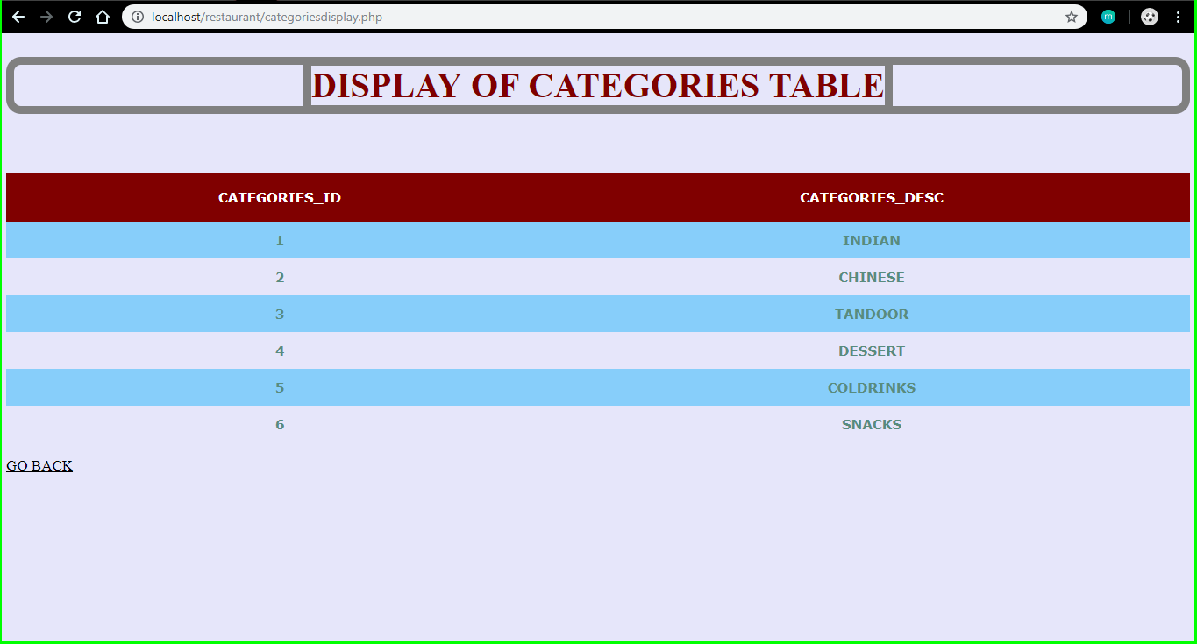

**FIGURE 7.6: DISPLAY FRONT END PAGE**

* This is the page where we can delete the record from front end which gets reflected in the back end.

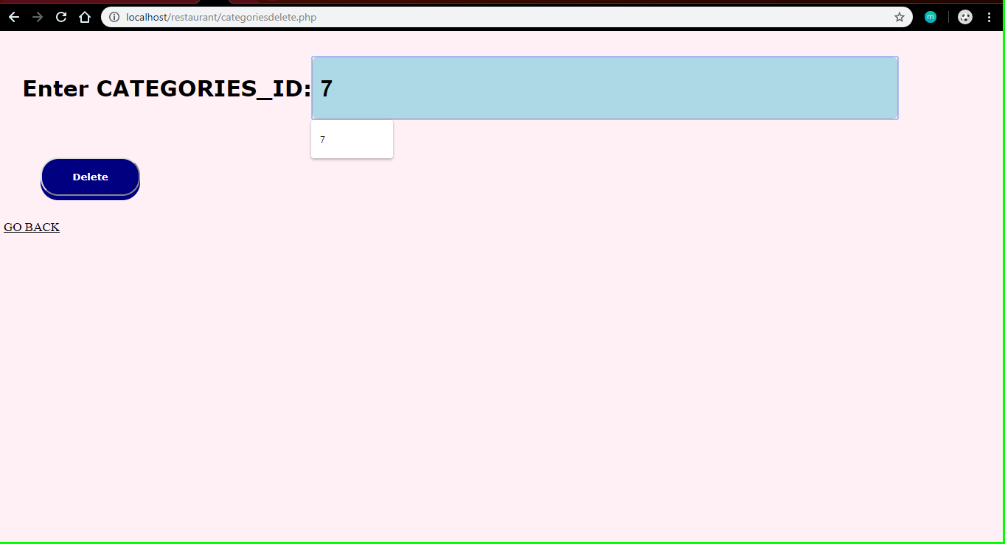

**FIGURE 7.7: DELETION PAGE**

* This is the page which displays the stored procedure at the front end.

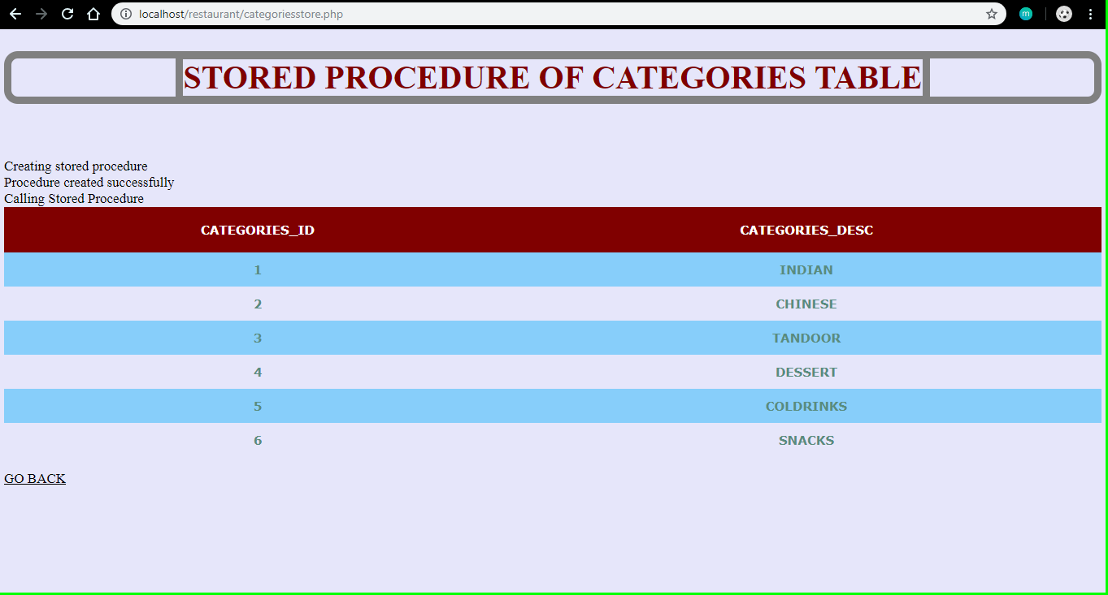

**FIGURE 7.8: STORED PROCEDURE FRONT END PAGE**

**CONCLUSION**

This database is a far more efficient mechanism to store and organize data than spreadsheets; it allows for a centralized facility that can easily be modified and quickly shared among multiple users. Having a web based front end removes the requirement of users having to understand and use a database directly, and allows users to connect from anywhere with an internet connection and a basic web browser. It also allows the possibility of queries to obtain information for various surveys.

This website provides a computerized version of restaurant management system which will benefit the staff of the restaurant.

**REFERENCES**

# 1.Fundamentals of Database Systems 7th Edition by [Ramez Elmasri](https://www.amazon.com/Ramez-Elmasri/e/B000APV0OK/ref=dp_byline_cont_book_1), [Shamkant B. Navathe](https://www.amazon.com/s/ref=dp_byline_sr_book_2?ie=UTF8&text=Shamkant+B.+Navathe&search-alias=books&field-author=Shamkant+B.+Navathe&sort=relevancerank).

2.Database management systems 3rd edition by Raghu Ramakrishna

3. PHP and MySQL Web Development by[Luke Welling](https://www.google.co.in/search?tbo=p&tbm=bks&q=inauthor:%22Luke+Welling%22&source=gbs_metadata_r&cad=6), [Laura Thomson](https://www.google.co.in/search?tbo=p&tbm=bks&q=inauthor:%22Laura+Thomson%22&source=gbs_metadata_r&cad=6)

4. For front end design <https://www.w3schools.com/html>